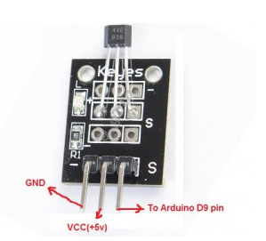
In this project, we will use a magnetic iron to test Hall sensor. When magnetic field is detected by Hall Sensor Module, the LED on the sensor module will turn on and LED of D9 pin will turn off.
Step 1: Connect Hall magnetic sensor to Arduino as per following graph:
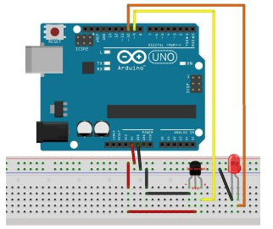
Step 2:Download Hall Magnetic Sensor Sketch Code, load it into Arduino IDE.
Step 3: Bring a magnetic iron(i.e. a waste speaker, a fridge magnetic sticker etc) close to the hall sensor. The light in the sensor module will turn on and the LED in circuit will turn off.

